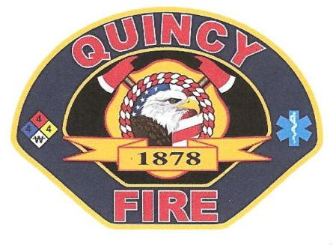Quincy Fire Protection District
Public Notice Pursuant to code 54950-54963
Board of Commissioners
Meeting Agenda
Mar 14, 2020 – 7:30 a.m.
Feather River Bulletin Conference Room
Any Item on the agenda may be taken up at any time in any order
- Call to order ( Chairman Taborski

- Public comments

- No meeting minutes to approve due to COVID-19

- Financial Reports ( Treasurer Andrew Ryback)

- Financials
- Review and sign claims

- Fire Chiefs Report ( Chief Cassou)

- Other Business

- Long term Building plans, discussion, and possible actions
- COVID-19 Information and updates
- SCBA- Maintenance & testing
- Online training- Weekly drill night

- Adjournment

